**Project Design Phase-I**

**Solution Architecture**

|  |  |
| --- | --- |
| Date | 10 October 2022 |
| Team ID | PNT2022TMID51128 |
| Project Name | Project - IoT Based Safety Gadget for Child Safety Monitoring and Notification |
| Maximum Marks | 4 Marks |

**Example - Solution Architecture Diagram:**

**System overview of wearable device:**

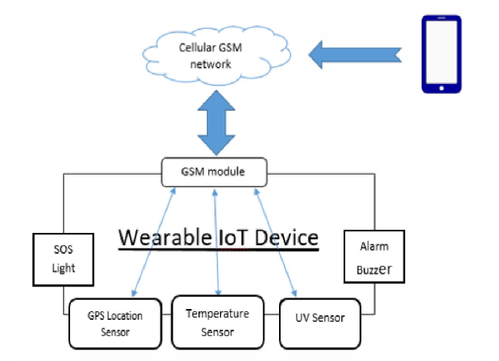

The wearable child safety gadget has the ability to function as a smart IOT device. It gives parents the opportunity to locate their child and alert passersby to act to rescue or comfort the youngster in addition to giving their child's surroundings real-time position, temperature, and an SOS light with a distress alarm buzzer.

**Architecture Design:**

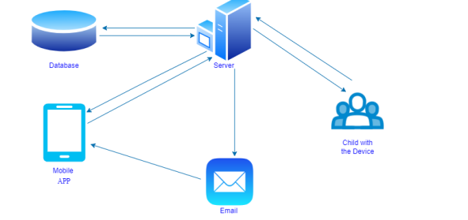

Nowadays, crime rates, particularly kidnappings of children, are on the rise. Furthermore, it is not always feasible to be there with them because most parents must work to support their families. The suggested approach has the potential to minimize the number of child missing instances. This system provides a tracking tool for parents to track their child's whereabouts outside utilizing WFPS, allowing them to know the exact location of the youngster. Furthermore, contribute to preventing this tragedy from recurring in the future.

**Network Architecture:**

